|  |  |
| --- | --- |
| **Date : 19/09/2023** | **Établissement : JJH** |

|  |
| --- |
| **Activité: The dangers of social media** |

Pj : Diaporama Capsules ou vidéos

Article de presse Mur virtuel Aut



**LISTENING COMPREHENSION**

**Name: ......………………………………………………..**

**ETLV no.5**

**Social media**

**Lesson no.2: The dangers of social media**

**1) Watch the trailer of a documentary entitled “LIKE” and answer the questions in English (use available dictionaries if needed).**

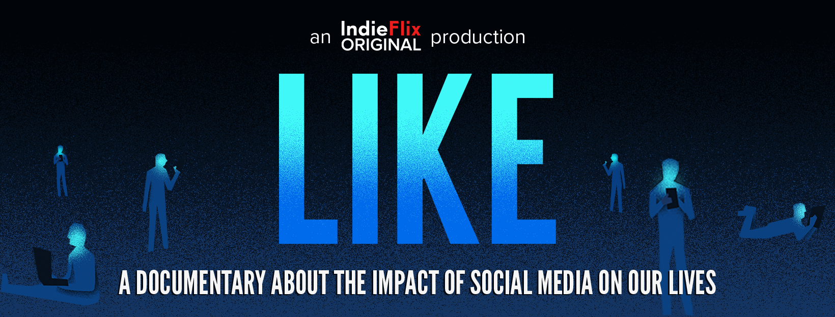

Source: iNDIEFLIX, “LIKE Trailer”, [YouTube.com](https://www.youtube.com/watch?v=9qVi63wG2OM), 26th March 2019.

What is a social media?

……………………………………………………………………………………….................

……………………………………………………………………………………….................

What is the purpose of a social media?

……………………………………………………………………………………….................

……………………………………………………………………………………….................

What is addiction to Internet?

……………………………………………………………………………………….................

……………………………………………………………………………………….................

Do we use our phones or do our phones use us?

……………………………………………………………………………………….................

……………………………………………………………………………………….................

……………………………………………………………………………………….................

What is the difference between the physical world and the virtual world?

……………………………………………………………………………………….................

……………………………………………………………………………………….................

……………………………………………………………………………………….................

What are the dangers of social media?

……………………………………………………………………………………….................

……………………………………………………………………………………….................

**2) Watch an extract of “Nosedive”, the first episode in the third series of *Black Mirror* and explain the following in French (dictionaries no longer permitted):**

Definition of “*nosedive”* by [Cambridge Dictionary](https://dictionary.cambridge.org/dictionary/english/nosedive): *“to suddenly fall in value, quickly and by a large amount”*

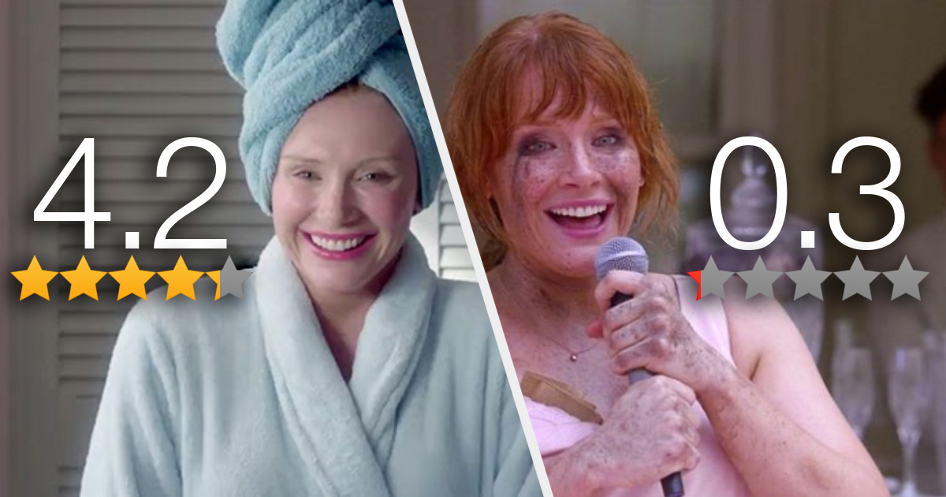

Source: Worldie - Social Media for Good, “Black Mirror - Lacie Rates Coworker - Social Credit System (Nosedive S3E1)”, [YouTube.com](https://www.youtube.com/watch?v=WTbbSZg4A3k), 6th August 2019.

What are the dangers of social media according to this British dystopian science fiction anthology television series?

……………………………………………………………………………………….................

……………………………………………………………………………………….................

……………………………………………………………………………………….................

……………………………………………………………………………………….................

……………………………………………………………………………………….................

……………………………………………………………………………………….................

……………………………………………………………………………………….................

……………………………………………………………………………………….................

……………………………………………………………………………………….................

……………………………………………………………………………………….................

**Teachers’ comments:**