Bloby’s sporulation microscopic observations

We worked on the development of the blob and have the mission to affirm the life cycle of this one.

First of all, we analyzed the sporulation of the blob under the microscope: below

Materials:

-microscope -spores -observation slide -distilled water -camera

**Protocol 1:**

1) Prepare an observation slide with spores: place the spores on the slide with a drop of distilled water then place the thin glass plate on top.

2) Place the slide on the microscope and analyze with the different magnification and take a picture.

3) Annotate the image.

Photography of spores cases of a blob in microscope (magnification x100)



Spores

Sporangium

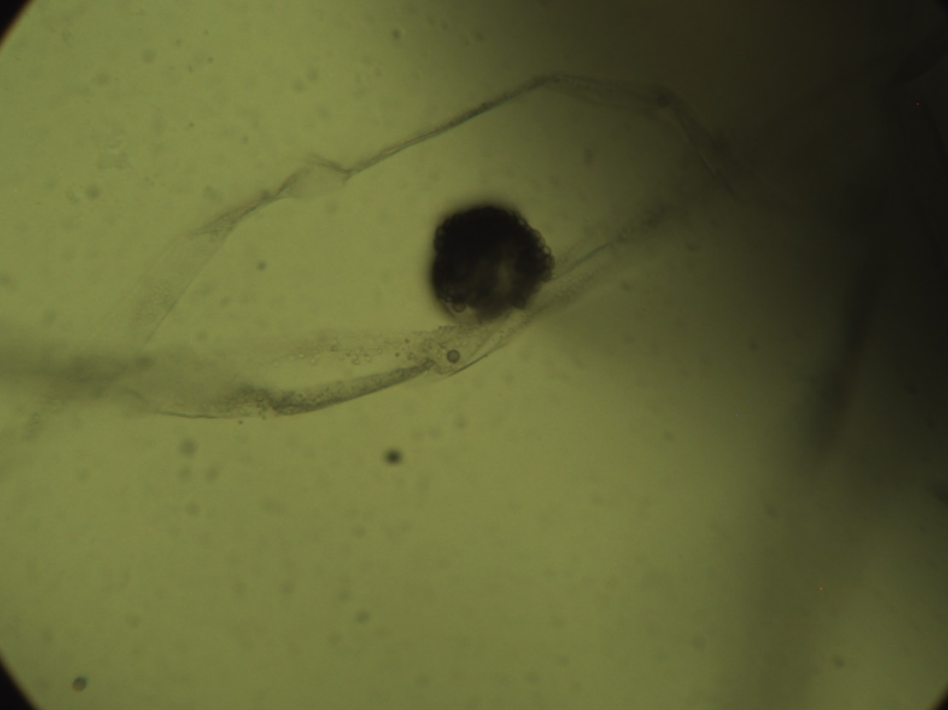Photographies of spores in microscope (magnification x400)

Blob spores

**Protocol 2:**

Perform the same steps as protocol 1 with this time crush spores (from the beginning).

Photography of crushed spores in microscope (magnification 400x)

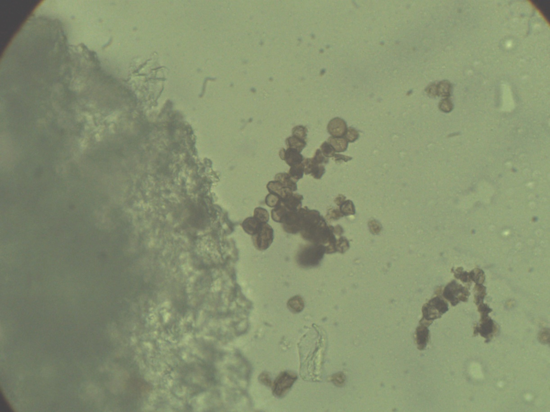

Sporangium

Blob spores (reproductive cells)

As we can see in these pictures, the blob contains spores on the top of the sporangium. These spores are the reproductive cells of the blob and contribute of the cycle life of the blob.

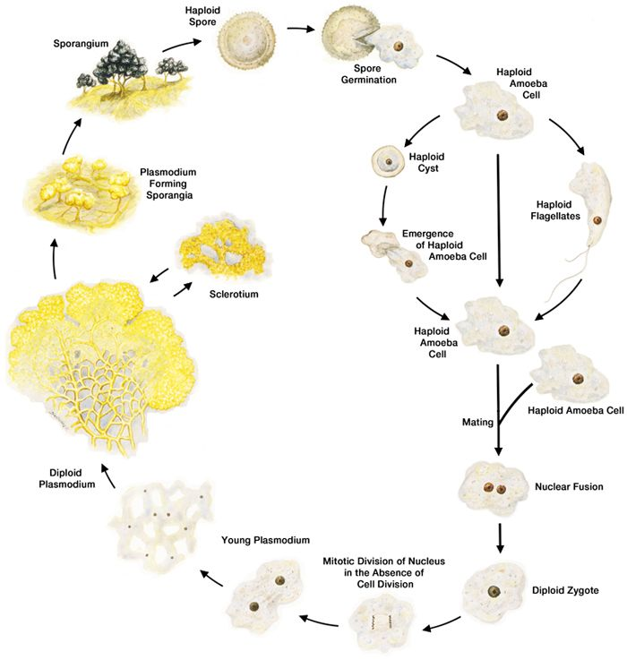Blob cycle life :

Finally, the results are not able to give a conclusion of our work because when we saw the Liam experience’s the crashed spores doesn’t develop the blob while the experience with normal spores develop the blob.